Project Planning Phase JIRA FILES

|  |  |
| --- | --- |
| Date | 20 November 2022 |
| Team ID | PNT2022TMID52418 |
| Project Name | AI-based localization and classification of skin disease with erythema |

TOOL USED: JIRA SOFTWARE OF ATLASSIAN

# Roadmap

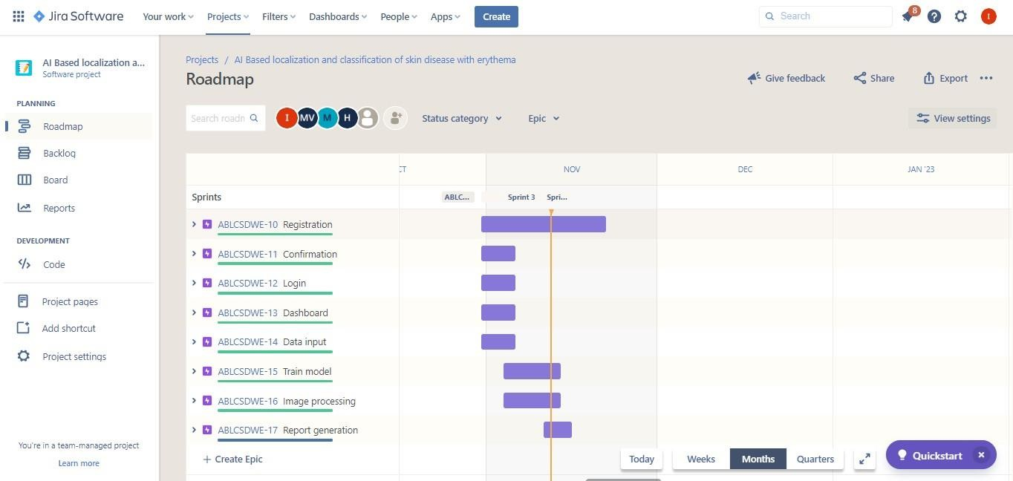

Backlog

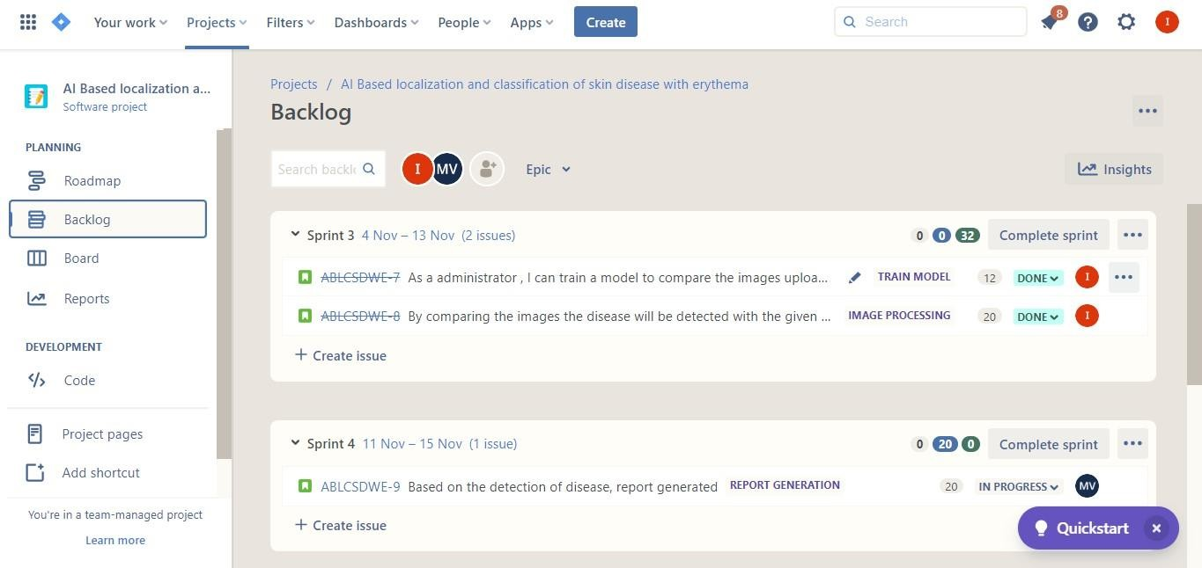

# Board

